Hot House Guidelines
ITS-GL012A, Ver 1.1


Sharda Centre, Off Karve Road, Erandwane,
Pune, Maharashtra, India 411004

www.techmahindra.com
Table of Contents

1. PURPOSE 3
2. SCOPE 3
3. Definitions & Acronymns 3
3.1. Definitions 3
3.2. Acronyms 3
4. SUITABILITY 3
5. METHODOLOGY OVERVIEW 4
5.1. What is a Hothouse? 4
6. PHASE DESCRIPTIONS 7
6.1. Hot House Process flow 7
6.2. Pre-Hot House 7
6.3. Planning the Hothouse 8
6.3.1 Scope and Budget 8
6.3.2 Team Formation 8
6.3.3 Scheduling of events 8
6.4. Conducting the Hothouse 8
6.4.1 Setting the context for the Hot House 8
6.4.2 Establishing rules of engagement for the Hot House 8
6.4.3 Business Requirements Development & prototyping 9
6.4.4 Validation of requirements and proposed solutions 9
6.5. Post Hot House Activities 10
6.6. Post Hot House - Review and Learning 11
6.7. A typical Hot House Scenario 11
7. DOCUMENT HISTORY 12
8. ANNEXURE A: TAILORING GUIDELINES 13
9. Template Document History 13

PURPOSE
This document describes the process to be followed while implementing Hot House during the execution of Agile projects.

SCOPE
The guidelines enumerate about hot house and steps to be followed for effective implementation for agile projects.

Definitions & Acronymns

Definitions
Keyword | Definition

Acronyms
Acronym | Explanation

SUITABILITY
Hot Housing and the 90-day cycle
Hot Housing has become a regular feature of doing business with our customers. Sometimes they are part of the 90-day delivery cycle. Sometimes a Hothouse is a part of the pre-sales activity. Teams from competing vendors are invited by customer to produce a prototype of a solution and give a presentation. Sometimes a hothouse is conducted with the expectation to arrive at a solution to a business problem and sometimes it is conducted to define requirements.
It forms part of the overall 90-day delivery process. As part of that process the expectation is that each program should hold a hothouse event at the beginning of the cycle. That is not to say that the hot housing technique could not be used effectively at other times, but the general principle is that the cycle is "kick-started" by a hothouse.
The hothouse is where development work to be produced over the next 90 days is prototyped and agreed, and following which targets and measures can be set.
The hothouse brings together all the key stakeholders to engage, build and refine prototypes and use these to agree on the next 90-day delivery – so it's critical that it's given every chance of success. This means that all necessary participants attend – from business partners and delivery teams, to people from Operational Integrity and the PIR (post-implementation review) team.
Depending on the type and size of the program, and its objectives, some program may hold more than one hothouse for a 90-day cycle.
Once the hothouse has been completed, the program should then define and agree its PIR targets and measures for the 90-day cycle. These are captured in a "90-day targets document" within 10 days of the end of a hothouse, and agreed in a "handshake" session with the PIR team.

This document briefly lays out guidelines for a hothouse. Audience for this could be business users, sponsors, solution and component designers, business process owners, project managers, requirements gathering team and developers.

METHODOLOGY OVERVIEW

What is a Hothouse?
Hothouse is a workshop for collaborative development of business requirements and design/solutions for business problems, which have quantified business benefits.

    - The 3 days of a hothouse
A hothouse event runs over an intensive three-day period, to ensure a shared understanding of the business problems is achieved and to nurture a strong team working ethos. A successful hothouse would normally involve three or more competing teams each tackling a business problem. The teams create prototypes which encapsulate the understanding of the business problem resulting in feasible, costable solutions that can be implemented in the remainder of the 90-day cycle. A preferred solution is chosen from among the competing prototypes and the winning team is rewarded. There are typically six to eight people in a team and, for practical purposes, up to about six or seven teams at an event.
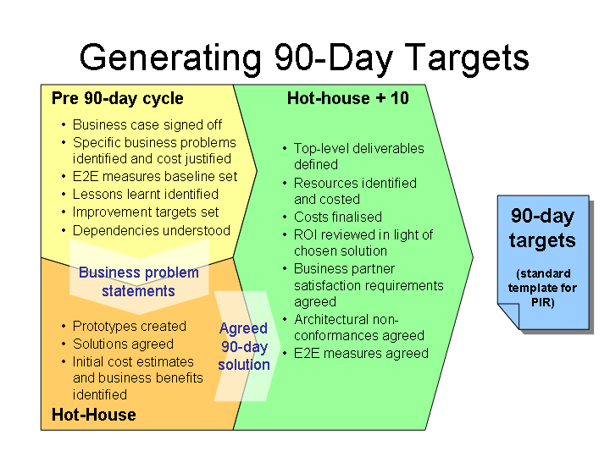

    - Hot House objectives
The objectives of Hothouse are
- Alignment to Agile delivery methodology
- Creation of streams focused on the business requirements
- Prototyping for the requirements through user-developer interworking
- To establish clear line of sight between business users, business process owners on one end and component designers, integrators on the other
- To produce agreed requirements and solution design prototypes/approaches that can be signed off.
- Creating sense of joint ownership/responsibility in the users and developers
- To establish clear delivery scope that can be committed to.
To radically reduce overall delivery timescales as all interdependent team representatives are present to take quick decisions.

    - Principles of Hot House
To achieve the desired objectives the hothouses should run on following principles
- Business problem for the hot house should have quantifiable benefits
- Identification of all the key stakeholders in the business problem for the hothouse. The list includes
  - Sponsors
  - Business users from each requirements area
  - Business Process Owners
  - Solution and component designers
  - End users of internally interfacing systems
  - Requirements gathering team
  - Designers of business process solution, system and network
  - Delivery team
And other teams like security compliance teams, architecture
Conformance teams etc could also be invited, if desired
- Right balance of time
There should be sufficient time for 2 iterations of solutions created and judged. There must be at least one demonstration from all teams each day. Normally 3 days is ideal time for hothouse durations
- Encourage competition.
Teams in the hothouses should be encouraged to compete with one another. It is strongly recommended, but not absolutely required, that any business problem tackled in a hothouse have at least two teams competing on it. Competition enables exploring of multiple options and assessing them in an effective way.

    - Participants in the Hot House
Most of the work within a hothouse is done by the teams competing to build prototype solutions. The ideal size for these teams is about 6-8 people.
Following points may be looked at while selecting a team:
- What are the core technical and business skills?
- What kind of people will work well in such environment?
- People with process, design or architecture skills as well as problem domain-specific expertise
- People capable of putting together the supporting materials -- cost estimates, benefits, presentation materials etc. -- for the teams.
- Who can be a leader to drive each team through to completion? The leader will usually have a good understanding of the business problem area to be tackled before the hothouse, although they may not be the primary expert.
It is suggested to have sufficient people (normally at least two) with the right skills within each team to be able to construct a credible prototype. Think also about having
If Organization is the only vendor participating, resources that will not be needed full-time by a team may be made available from a pool of shared resources (and it may be possible to "trade" for expertise between teams). Teams are also free to "phone a friend" and call on people outside the hothouse to perform particular tasks, if necessary!
    - Key Roles

- Business lead: Owns a business problem being tackled by the hothouse.
- Programme lead: The prime contact within the programme, responsible for working with business and event leads to deliver the hothouse.
- Event lead: A member of the hothouse team who advises the programme and business leads and runs the hothouse event.
- Team lead: Leads a team at the hothouse. May be involved in planning and usually has prior understanding of the business problem area.
- Business and programme sponsors: Senior representatives who may not participate in the whole hothouse but will give it high-level backing.
- Programme administrative support: A person within the programme who will manage attendance, hotel accommodation, catering etc.
- Programme technical lead: A person within the programme to co-ordinate preparation of the infrastructure
- Team members: The people who will do design, coding, testing, verification and presentation of the prototype.

    - Inputs to a hot house
The main input to a hothouse, apart from the people involved, is a set of one or more business problems that needs to be solved. While it is very useful to have material (maybe a slide or two) that briefly articulates the problem, the most crucial aspect for the success of the hothouse is to have business partners present who understand the problem. The problem statements should be backed up by evidence (e.g. market research) that solving this problem effectively will result in tangible business benefits, that there will be a real ROI.
There are some other pre-requisite activities that must have been performed before entry into a hothouse. These are:
- Business case signed off
- E2E measures baselines set
- Previous lessons learnt identified
- Improvement targets set
- Dependencies identified

    - Outputs from a Hot House
The fundamental outputs from a hothouse are the prototypes created to demonstrate solutions to the business problems, and which can be taken forward as part of the 90-day delivery. However, there are a number of other outputs -- both tangible and less so -- that will be produced. Most importantly there should be agreement between the business and IT communities that the prototypes represent acceptable, achievable solutions to the business problems. This will be formally recorded as part of the "handshake" process.
Other outputs that may typically be generated include:
- initial cost and resource estimates
- identified benefits and possible ROI estimates
- process definitions or modifications
- refined requirements statements
- identified architectural non-compliances

All these information may be produced in the form of a Hot House Information Report.

    - The PIR Handshake
Hot Housing feeds into the overall 90-day delivery cycle and also have a linkage to the PIR (Post Implementation Review) process. In particular, while a hothouse can -- and should -- allow major deliverables for a 90-day cycle to be prototyped and agreed, there will still be work to be done to finalize costs, identify targets and measures for PIR, and to ensure that any dependencies or constraints that could not be addressed within the hothouse have been reviewed. This must all be done in the ten days following the end of the hothouse. At this point of "hothouse + 10" there is a "handshake" to formally agree the targets for the remainder of the 90-day cycle.

PHASE DESCRIPTIONS

Hot House Process flow
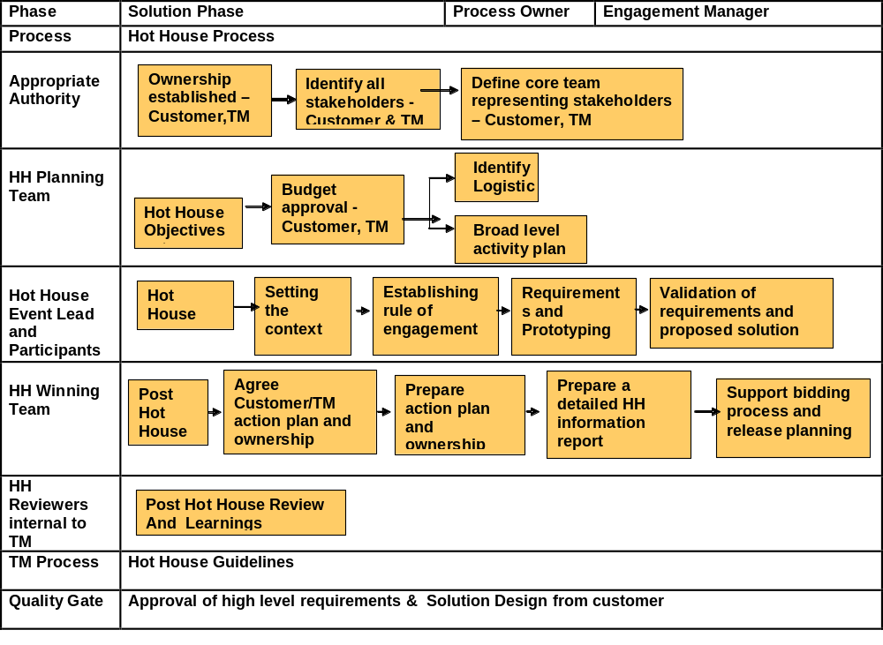

Pre-Hot House
- Ownership established in Customer end and Vendor
- Identify all stakeholders in Customer end & Vendor
- Define core team representing stakeholders – Customer end, Vendor

Planning the Hothouse

Scope and Budget
- Workshop/s to decide requirements scope and what should happen in the H.H.
- If bidding process precedes, ensure that inputs of bidding process go into H.H.
- Budget approved for project - Customer
- Budget approved for H.H.– Customer, Vendor
- Define / Understand H.H. Structure

Team Formation
- Identification of the participants for the Hothouse is most crucial set in planning out the Hothouse.
- Apart from the business sponsors, business process owners, business users include right proportion of business analysts, solution designers end users from the systems affected by the new development/ enhancement.
Other teams like security compliance teams, architecture conformance teams etc could also be invited, if desired
- Ensure that team size does not exceed 10. Ideal team size could be from range of 6-8. If teams are bigger then consider splitting the team into streams based on the business requirements
- Define teams and members, check availability

Scheduling of events
- Identify Logistics – Broad level of activity plan and schedule, team size, infrastructure requirement, people mobilization requirement
- Fix the start and end time for each day giving consideration to locations from where participants are coming
- Plan for adequate breaks
- Ensure teams in Hothouse have adequate infrastructure like rooms for discussions, white boards for discussions etc
- At end of each day there is sufficient time for
- Team presentations
- Voting on presentations
- Summarizing the developments during the day

Conducting the Hothouse

Setting the context for the Hot House
The objective of the step is to create a sense of joint ownership in the group. This will focus on removing the doubts / reservations in the minds of Hothouse participants.
- Clear objectives for the Hothouse should be set. This should include the expected outputs along with expected prototypes
- If participants are more than 15 then the groups should be split into different streams based on the business requirements
- Leader for the streams should be identified and entrusted with task ensuring the stream teams remain focused

Establishing rules of engagement for the Hot House
- Each stream in the Hothouse should present the prototype progress at end of each day to other streams. Each prototype is voted for. Votes could be from the team, from design team (Design Vote) and from the Business Users (Business Votes)
- Roles and responsibilities of the people involved should be arrived at through discussions

Business Requirements Development & prototyping
Hothouse team / stream teams can use various brain storming techniques for developing the prototype keeping in line with the objectives set for the team. Prototypes should aim at look and feel and may not be fully working. Normally prototypes should be constructed using the same technology that would we used for the ultimate delivery.
  - Each team prioritizes and scopes the functional requirements.
  - Breakout sessions continue to incorporate feedbacks and discussions.
  - Clear and detailed requirements are documented and agreed by all.
  - Costing and schedule implications of various design options are discussed.
  - Risks and assumptions are documented.
In cases where there are no changes in the functionality but involves a business process change the prototypes should demonstrate the business processes.

For non functional requirements like as resilience, scalability or security where prototype cannot be produced design options must be demonstrated and assessed and key tests and metrics should be agreed.

Validation of requirements and proposed solutions
Prototypes developed by the teams are presented at end of each day of Hothouse. These are validated by peer team members, design teams and business users. Each of the prototypes is scored based on the votes from participants in the Hothouse as per the agreed engagement rules at the time of inception of Hot House. Prototype team with highest votes should be rewarded. Delivery commitments are obtained from the teams involved.
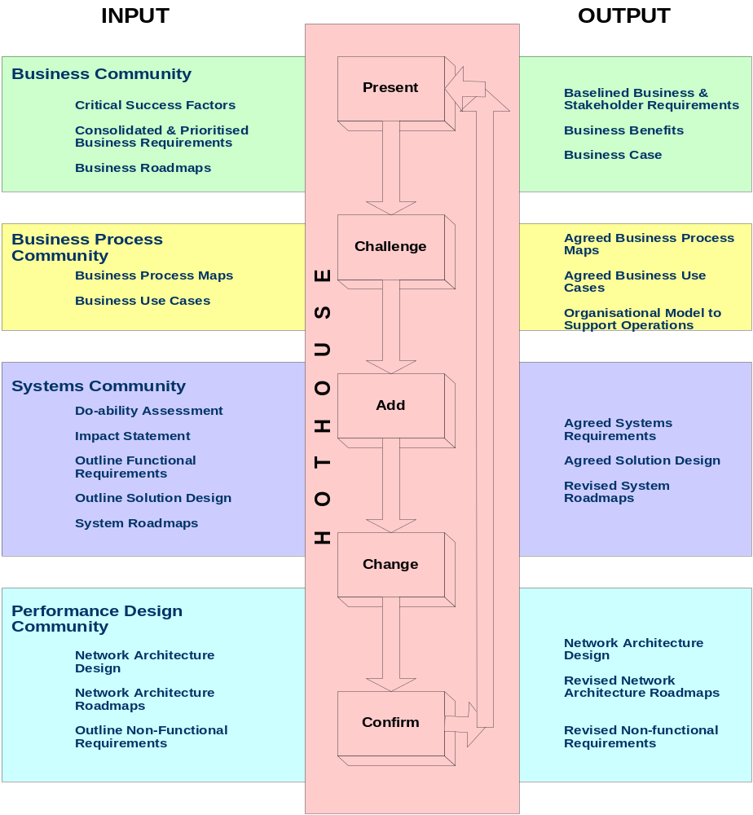

Post Hot House Activities
- Agree Customer/Vendor action plan and ownerships
- Agree Activities schedule and deliverables with Customer
- Prepare action plan and ownerships within Project
- Prepare a detailed H.H. information report
- If bidding process follows, ensure the H.H. inputs go into bidding process
- Follow up until contract stage
- Ensure that inputs of H.H. go into contract stage and into project planning

Post Hot House - Review and Learning
- Project Hot House Owner to ensure internal review of H.H. happens
- Delivery Managers, CDM, BDM, Participants of similar past H.H. can be reviewers
- Overall approach followed by us as well as other teams should be explained
- Were Customer’s expectations understood early? How were they addressed?
- Inherent / systemic strengths and weaknesses of us and where possible of competitors should be discussed
- What we did right and what we did wrong should be discussed (Same about competitors)
- Recommendations, action plan and learning should be the outcome. Learning to be posted on the website

A typical Hot House Scenario
- Sample Agenda for Hot House
DAY 1
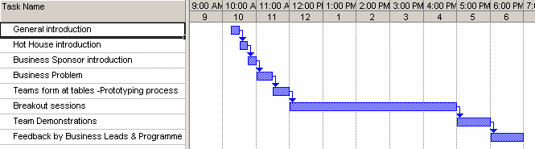
DAY 2
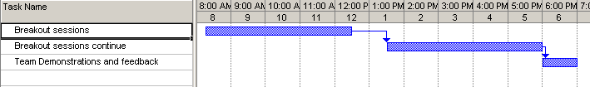
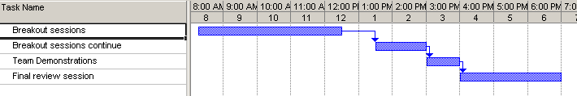
DAY 3

From the agenda above it is clear that in a hot house most of the time is spent towards breakout sessions which is used to come out with solutions for the given set of requirements.
- Strategy for the hothouse
  - Create streams (groups) to focus on business requirements
  - More than one prototype per stream
  - Streams compete with each other
  - Requirements – Detailing and Prioritization
  - Detailing acceptance criteria for the deliveries
  - Each stream to include 15-20 participants comprising Business users, IT and Project developers
- Lead Team
  - Hothouse Sponsor
  - Hothouse Convener
  - Lead User
  - User Interaction Mgmt
  - Business Requirements
- Voting - Everyday the streams will demonstrate the progress of prototypes. There will be voting after demos. The total score for 3 days will be counted. The prototype team with highest votes will win award.
  - Peer votes - everyone votes for the other team, no self voting
  - Programme / Design Vote - Programme Manager, Programme Design & Build reps vote
  - Business Vote -Senior Business reps vote
- Streams
  - Streams created based on the business requirements. Each stream will discuss the prototype requirements and then split into two sub-streams.
  - Sub-streams will work on the prototypes and assemble to discuss with the rest of the team
  - At the end of the day, streams will assemble for the demonstrations.
  - Stream Leaders will keep the time for the stream.
- Prototypes
  - Should aim at ‘look and feel’
  - May not be fully working
  - PowerPoint Slides only - not acceptable
- What makes a good problem?
  - Is there someone who owns and understands the problem?
  - If it is solved, will it result in real business benefit?
  - Do you know how much you are willing to spend on solving it?
  - Would a solution contain a large system element?
  - Can you envisage a solution, or at least a step towards a solution, being created in three days?

DOCUMENT HISTORY

Version | Date | Author | Reviewed by | Approved by | Nature of changes
1.0 | 19 Apr 2013 | Satya/Amit Ahuja | Shalini Joshi/Nidhi Saxena | Shalini Joshi/Nidhi Saxena | First Integrated Issue
1.1 | 01-August-2013 | Archana M | Senthilkumar S | Thenmozhi S | Ported template in new integrated template format post merger.

ANNEXURE
None.

